NAME: KARIUKI LISPER WAIGUMO

REG NO: BSCCS/2024/60096

COURSE/CLASS: BACHELORS OF SCIENCE IN COMPUTER SCIENCE

UNIT CODE: BIT3208

UNIT NAME: ADVANCED WEB DESIGN AND DEVELOPMENT

LECTURERER NAME: MICHAEL NYORO

SEMESTER/ ACADEMIC YEAR: SEMESTER 6

PROJECT DETAILS

PROJECT TITLE: LISPER/CHUM STORE

SELECTED TECHNOLOGIES: 1. PHP & SQL

GITHUB REPOSITORY LINK:

Upload files · risperkariuki068-png/Chum-Lisper-Store

TABLE OF CONTENTS

Table of Contents
WEEK 1: LOCAL ENVIRONMENT SETUP 5
Title: Installation and Testing of Local Development Environment 5
Fig 1: XAMPP 5
Fig 2: Apache and MySQL Running (Screenshot from XAMPP Control Panel) 6
Fig 3: Localhost Test page (Screenshot browser running localhost) 6
Fig 4: Hello World Test (Screenshot of first PHP or HTML page) 7
Figure 5: Database Connection Test (screenshot showing successful DB connection) 7
WEEK 2: Wireframes and GUI Design 8
Title: User Interface Planning and System Design 8
Fig 1: Hand- Drawn Wireframe 8
Fig 2: Dashboard Layout Design 9
Figure 3: Mobile View Mockup 10
Fig 4: Color Theme and Navigation Structure 11
Fig 5: GUI prototype in Figma/ Canva/ Draw.io 12
Week 3: JavaScript and PHP Basics 13
Title: Frontend Interaction and Backend Foundations 13
Fig 1: JavaScript Form Validation 13
Fig 2: Password Strength Checker 14
Fig 3: PHP Syntax Practice 15
Fig 4: Database Connection Script 15
Fig 5: Dynamic User Input Handling 16
Week 4: Dynamic Backend Processing, Authentication and Session Management 17
Title: System Implementation Summary 17
Fig 1: Login System Development 17
Fig 2: Login Page Interface 18
Fig 3: Database Connection Script 19
Fig 4: Users table in phpMyAdmin 19
Fig 5: Session Management 20
Week 5: Building Data-Driven Systems using Databases 21
Task 1: Introduction to Databases 21
Fig 1: Php showing the database successfully created. 21
Fig 2: Table Creation for users with ID, Username, and password fields 21
Fig 3: Insert Query adding a new customer 22
Fig 4: View records query displaying stored data 23
Fig 5: Edit query Updating User Information 24
Fig 6: Delete Query Removing a record successfully (codes) 25
WEEK 6 26
Title: Database Integration and CRUD functions 26
Fig 1: Connect to MySQL using db.php 26
Fig 2: CREATE Operations to Insert Products Records 26
Fig 3: READ Operation to Display Products Records 26
Fig 4: UPDATE Operation to edit products Records 27
Fig 5: DELETE Operation to delete product record 27
Reflection: 27
WEEK 7 28
Title: User Authentication and Session Management 28
Fig 1: Creating a User’s Table 28
28
Fig 2: User Registration System 29
Registration form 29
Fig 3: Processing Registration 30
Fig 4: Why use of Hash Passwords 30
Explanation for use of Harsh: 30
Task: Login System 31
Fig 1: Login Form 31
Fig 2: Login Processing 32
Task: Session Management 32
Fig 1: Starting a Session 32
Fig 2: Creating Session Variables 33
Fig 3: Protecting Pages 33
Task: Logout System 35
Fig 1: Logout Script 35
Reflection: 35

WEEK 1: LOCAL ENVIRONMENT SETUP

Title: Installation and Testing of Local Development Environment

Fig 1: XAMPP
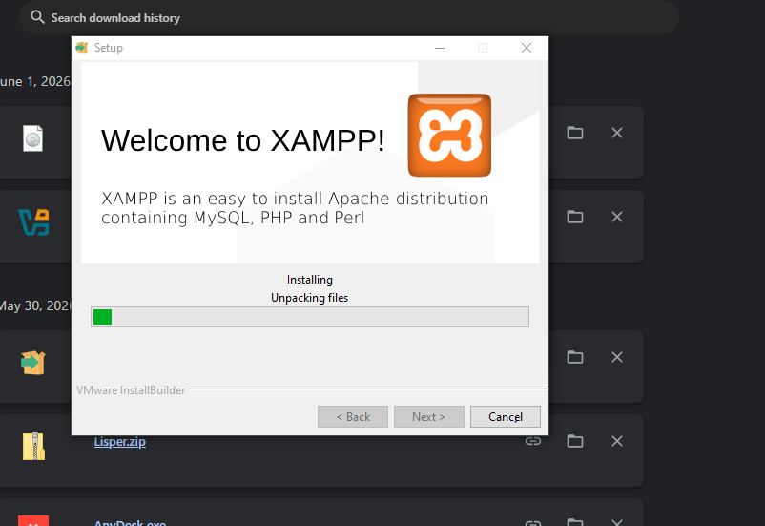

Fig 2: Apache and MySQL Running (Screenshot from XAMPP Control Panel)
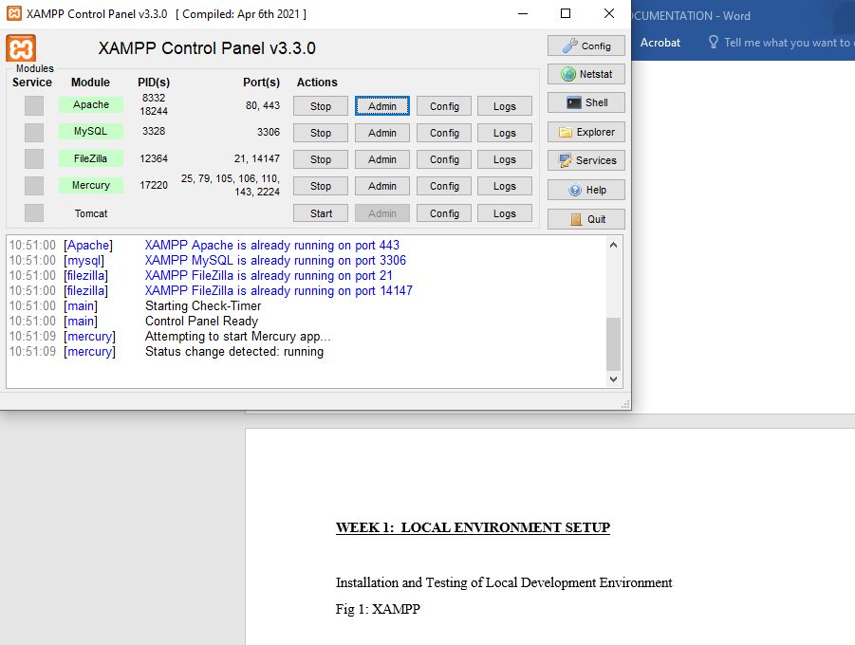

Fig 3: Localhost Test page (Screenshot browser running localhost)
I’m using fire fox to run the localhost.

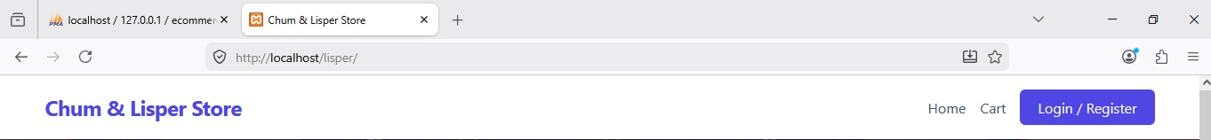

Fig 4: Hello World Test (Screenshot of first PHP or HTML page)
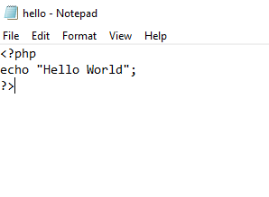

Figure 5: Database Connection Test (screenshot showing successful DB connection)
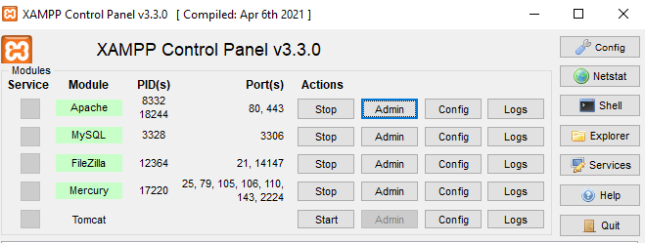
Reflection: Figure 5 shows the successful connection between PHP and MySQL. This confirms that Apache and MySQL services were properly configured in XAMPP.

WEEK 2: Wireframes and GUI Design

Title: User Interface Planning and System Design

Fig 1: Hand- Drawn Wireframe
(Login/Homepage)
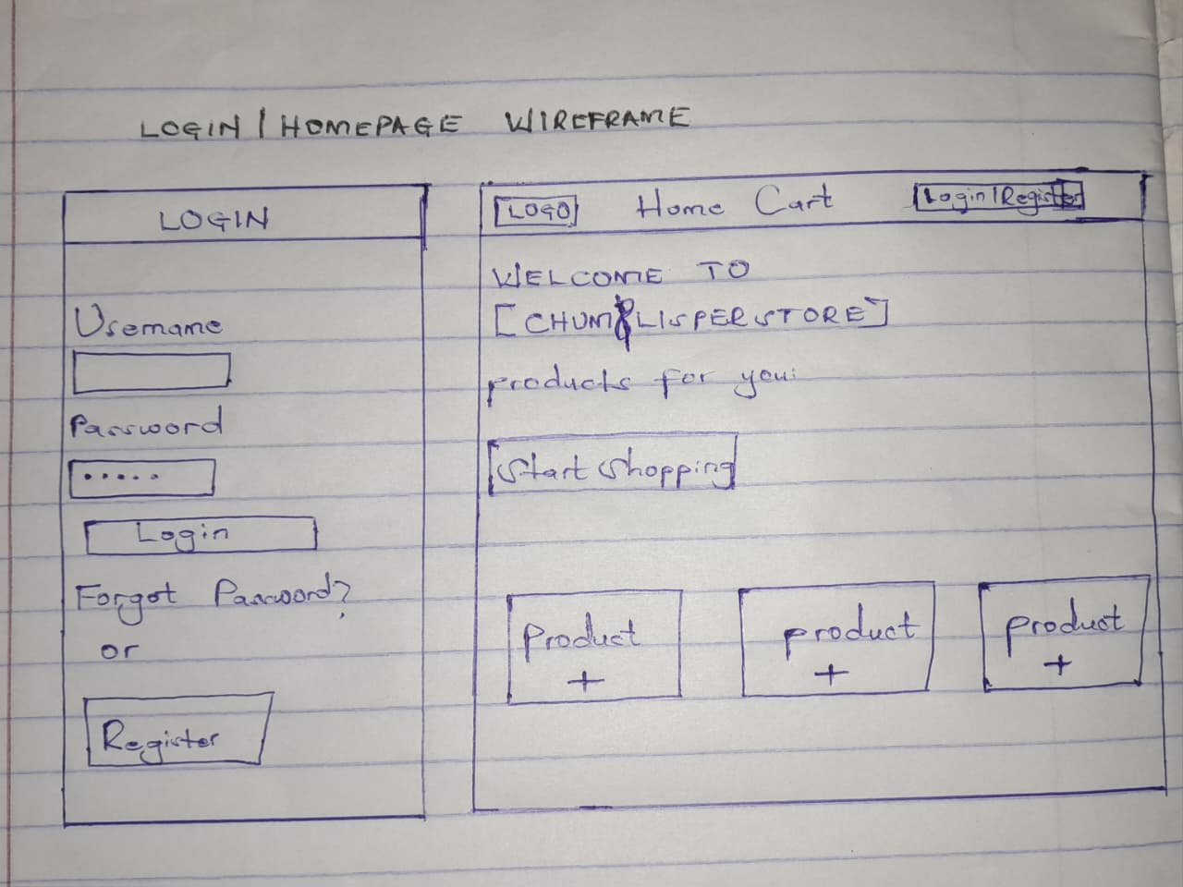

Fig 2: Dashboard Layout Design
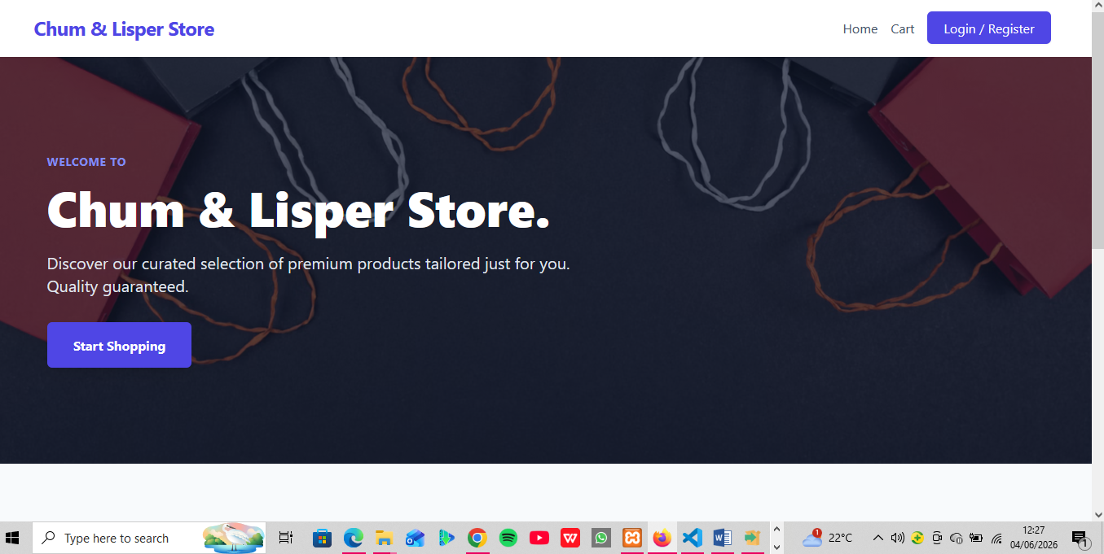

Figure 3: Mobile View Mockup


Fig 4: Color Theme and Navigation Structure


Fig 5: GUI prototype in Figma/ Canva/ Draw.io
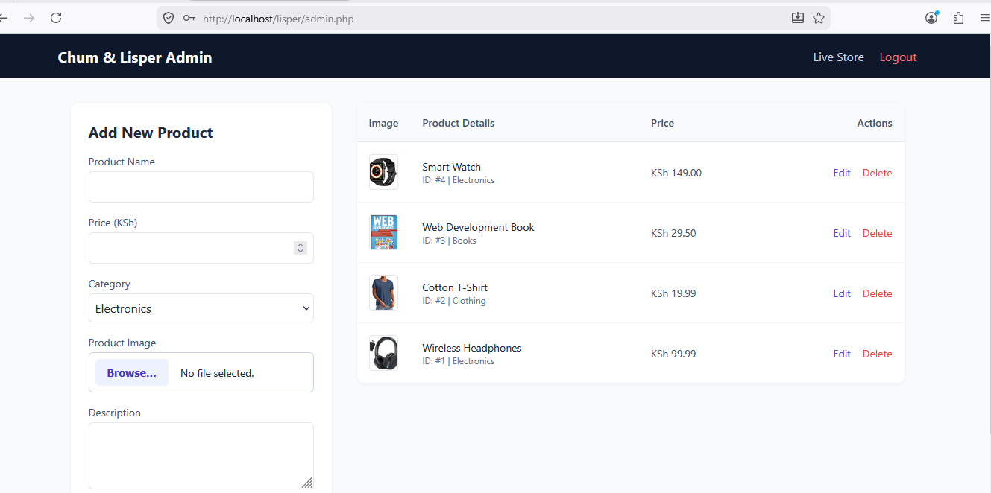

Reflection: The minimalist grid design was chosen for the Chum/Lisper store system to make browsing items clear and straightforward. To improve the user experience, I focused on reducing clutter so store admins and buyers wouldn't get overwhelmed. The navigation flow was planned to move users sequentially from selecting an item straight to the checkout page in as few clicks as possible. The system's intended users are everyday customers placing orders and store managers keeping track of stock, meaning the interface had to be simple, fast, and easy to learn.

Week 3: JavaScript and PHP Basics

Title: Frontend Interaction and Backend Foundations

Fig 1: JavaScript Form Validation
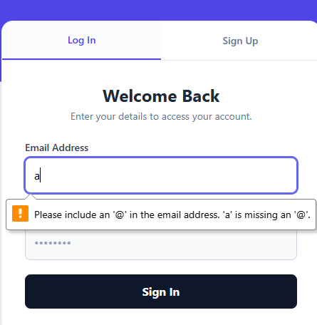

Fig 2: Password Strength Checker
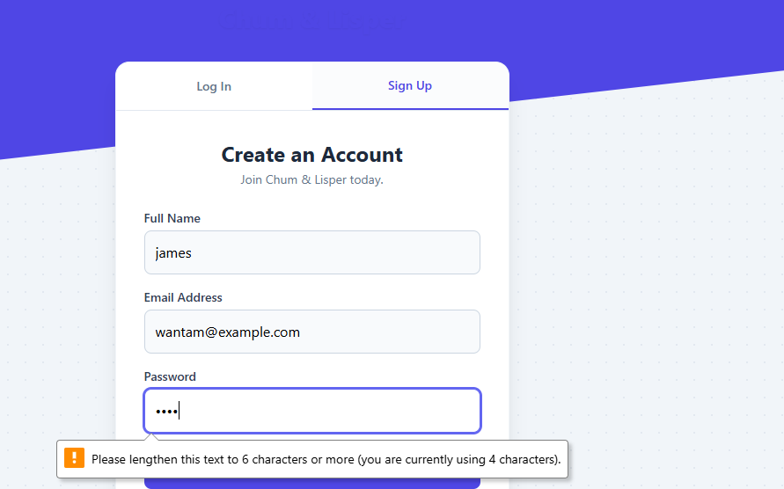

Fig 3: PHP Syntax Practice
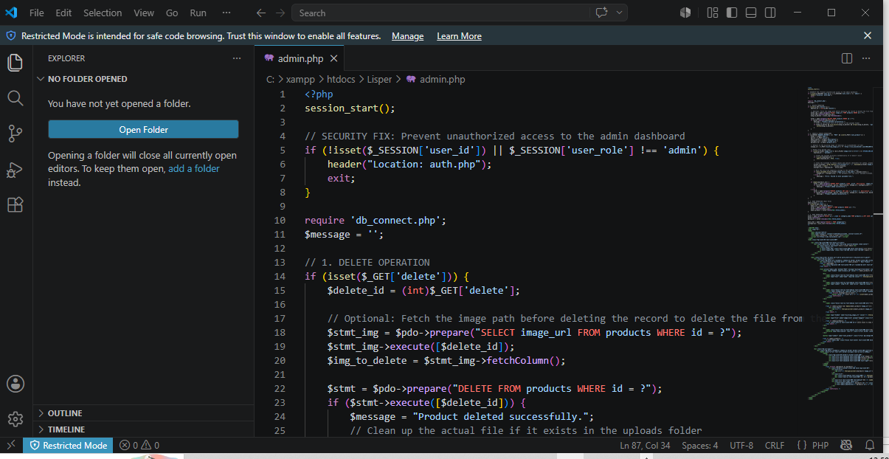

Fig 4: Database Connection Script


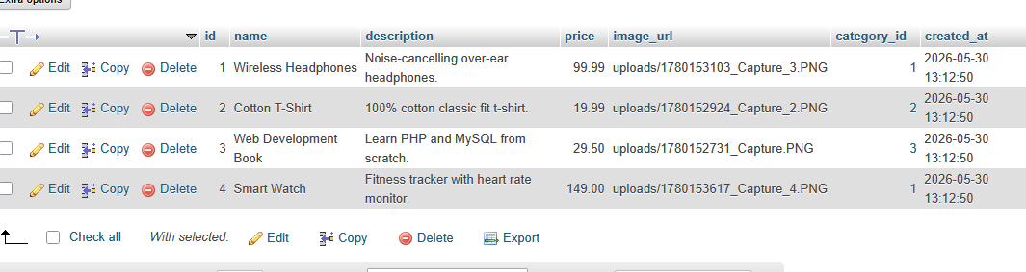

Fig 5: Dynamic User Input Handling
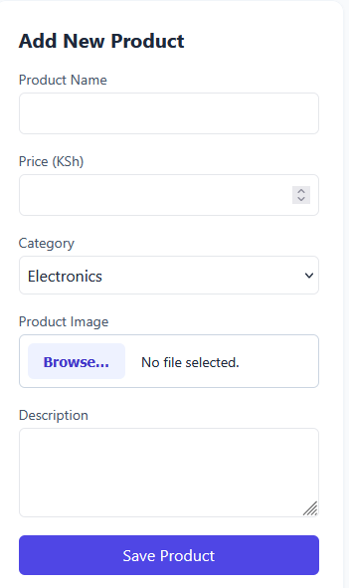
Reflection: This week involved implementing basic frontend and backend functionality for the Chum/Lisper store order-management system. JavaScript was used to validate order form inputs and prevent submission of empty fields, improving user experience before data is sent to the server. PHP was used to process order submissions and authenticate store credentials. The integration of JavaScript and PHP improved system reliability by ensuring proper data handling and validation before processing

Week 4: Dynamic Backend Processing, Authentication and Session Management

Title: System Implementation Summary

A login system was created to authenticate users before accessing the system.

Fig 1: Login System Development
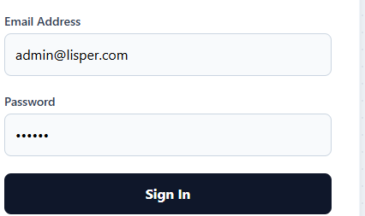

Fig 2: Login Page Interface
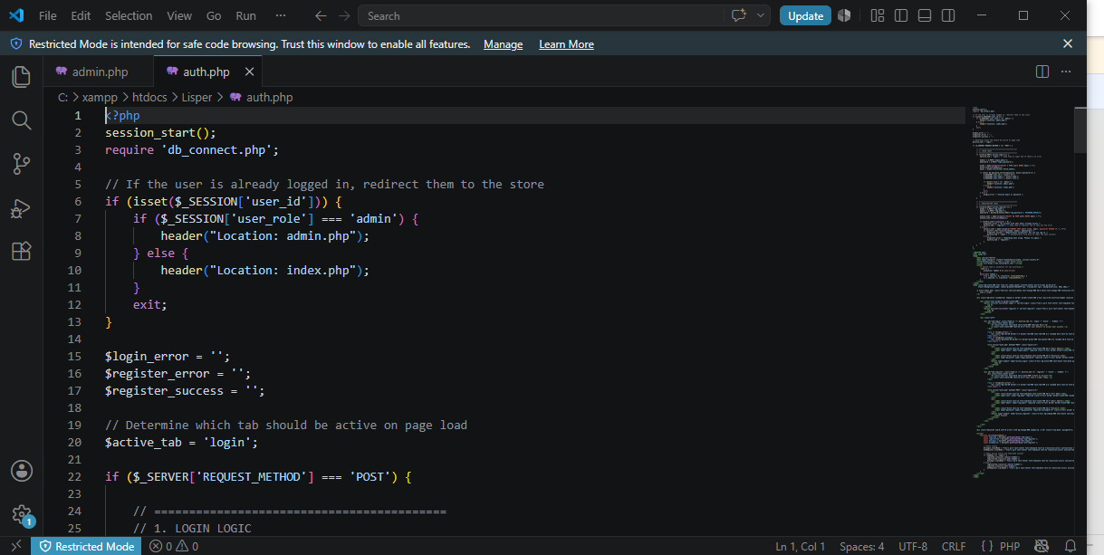

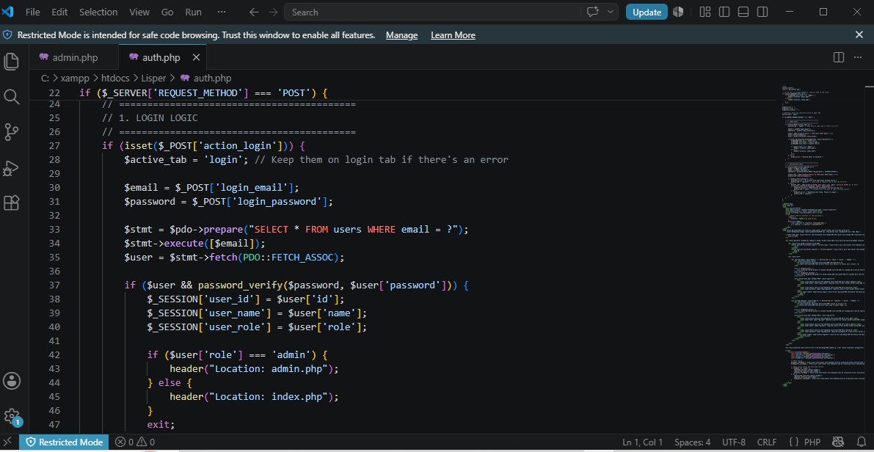

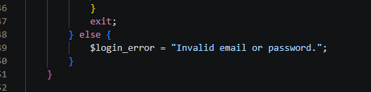

Fig 3: Database Connection Script
Users Table Created to store the user’s login details.
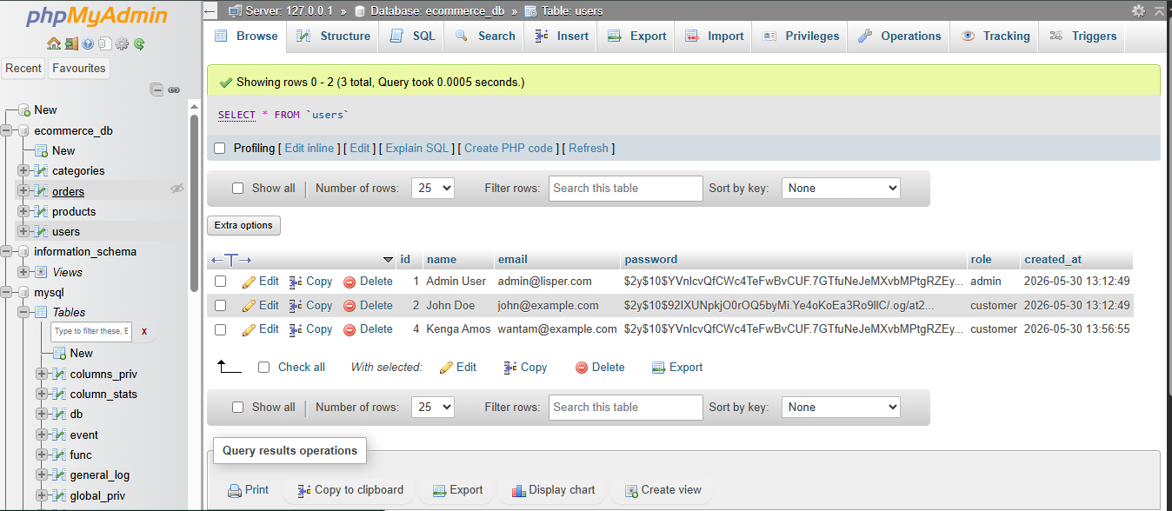

Fig 4: Users table in phpMyAdmin
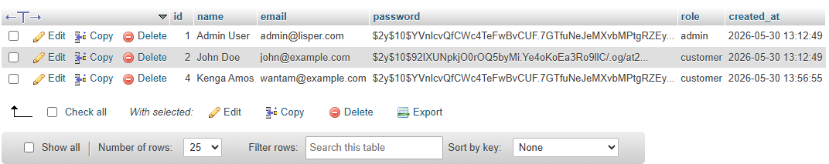

Fig 5: Session Management
To maintain user login state after successful authentication

Fig 6: Successful Login Session (Dashboard View)
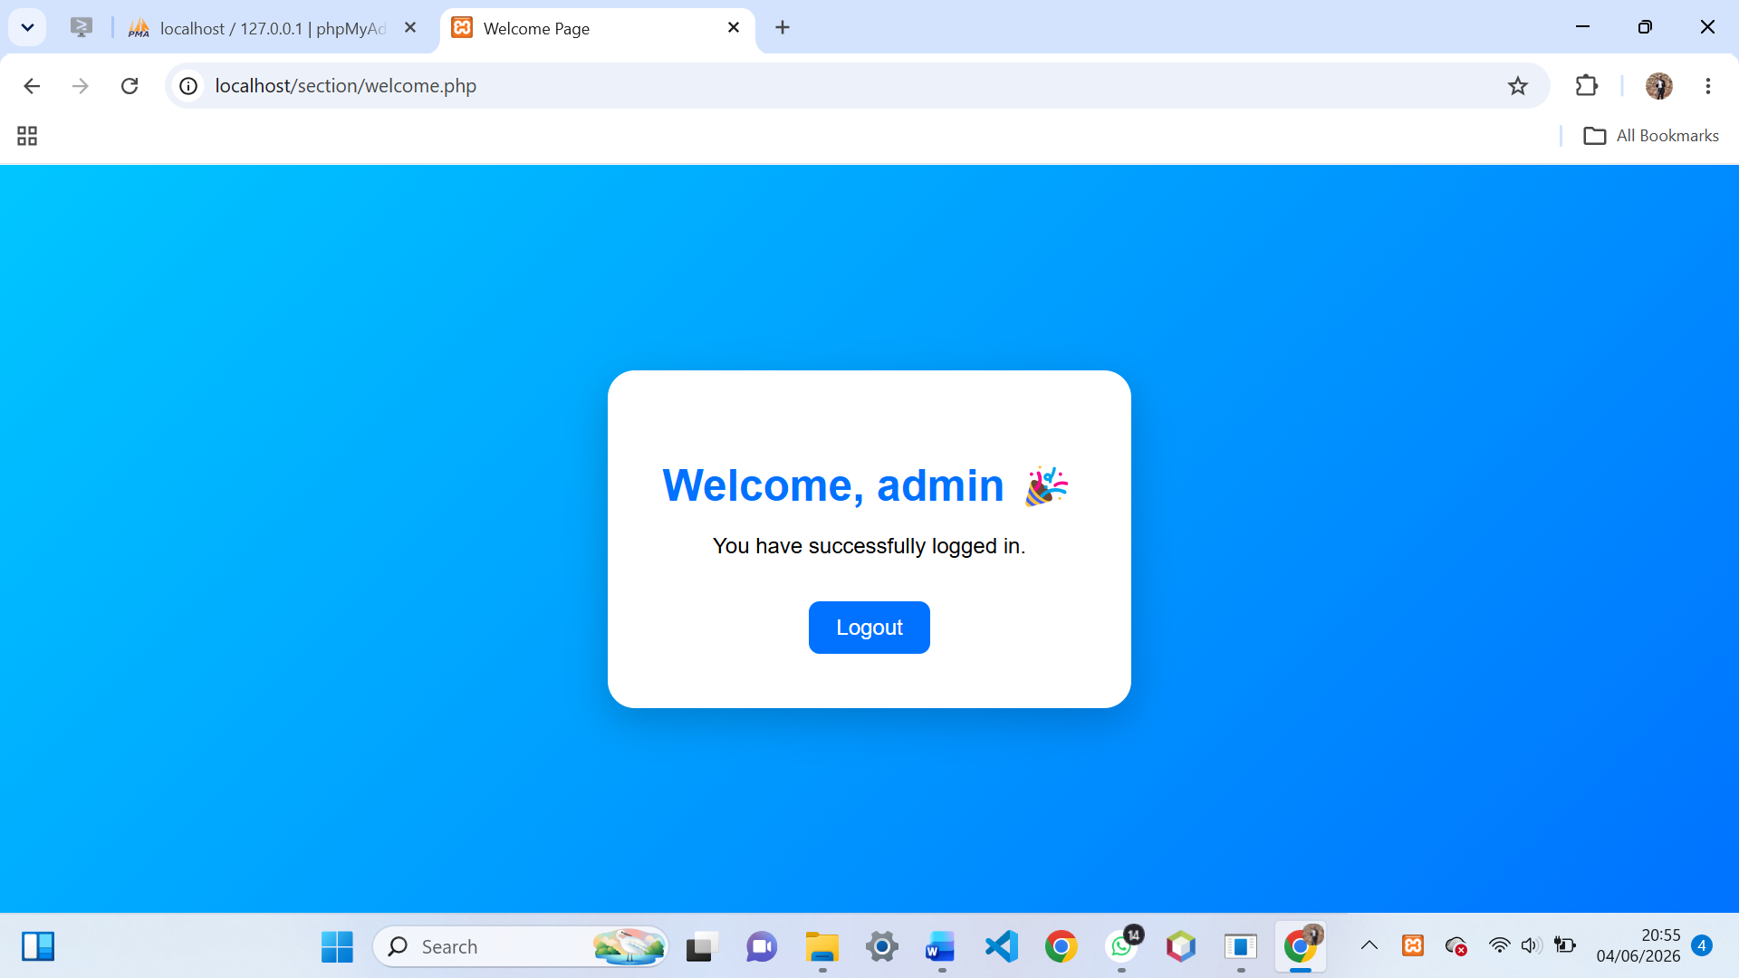

Reflection:
Week 4 focused on backend processing, authentication, and session management. A login system was successfully implemented using PHP and MySQL. Sessions were used to control access to the dashboard. Challenges included database connection errors and session handling issues which were resolved through debugging and testing.

Week 5: Building Data-Driven Systems using Databases

Task 1: Introduction to Databases

Fig 1: Php showing the database successfully created.
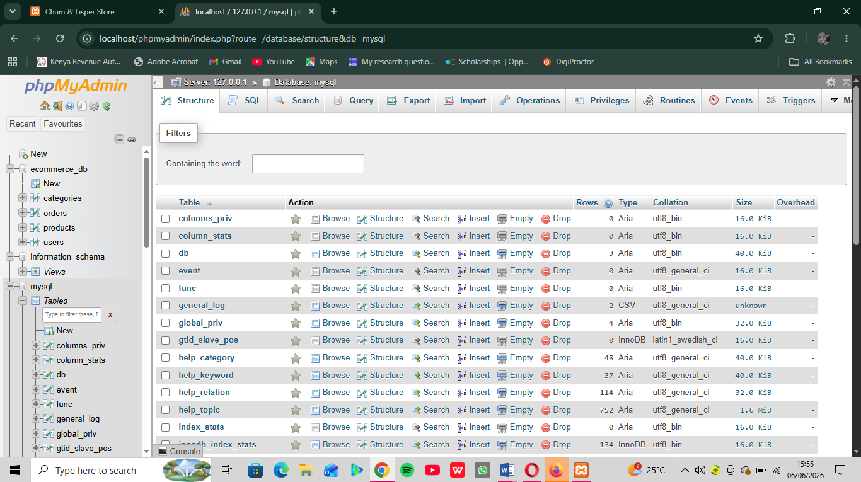

Fig 2: Table Creation for users with ID, Username, and password fields
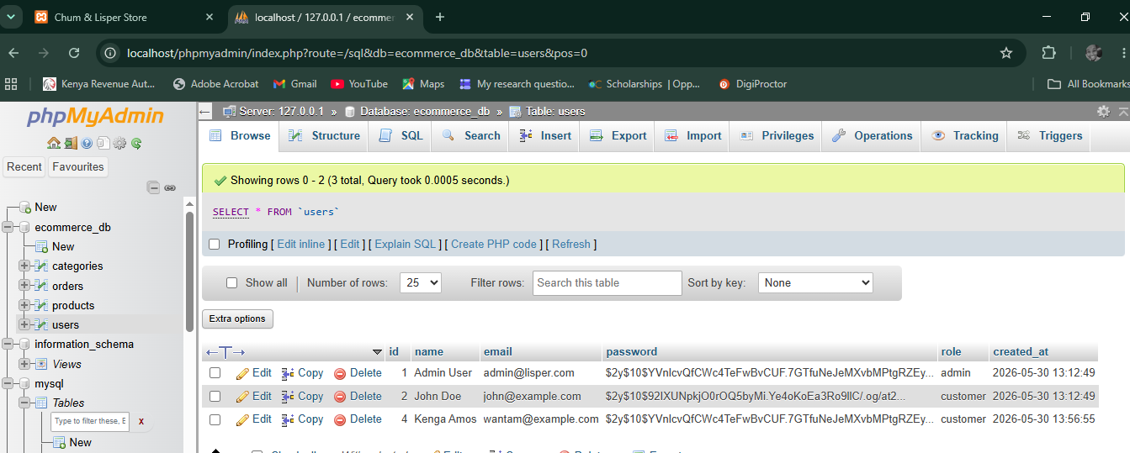

Fig 3: Insert Query adding a new customer
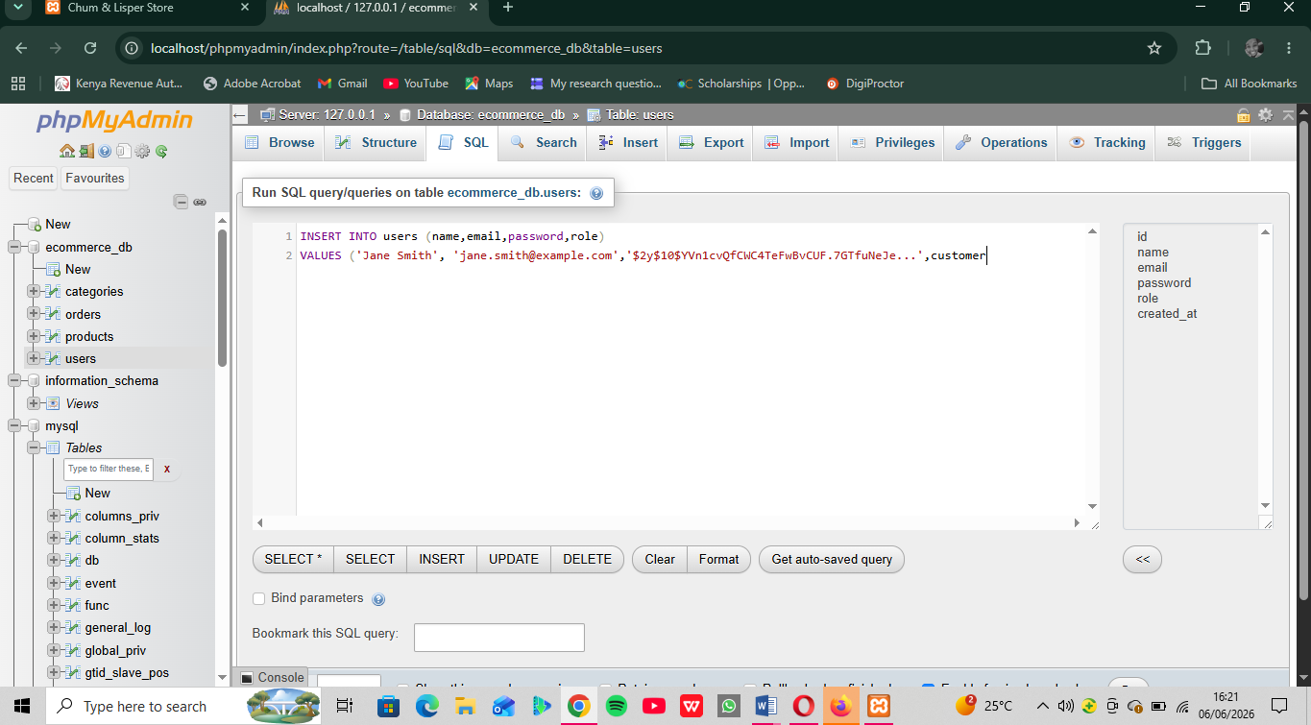

Fig 4: View records query displaying stored data
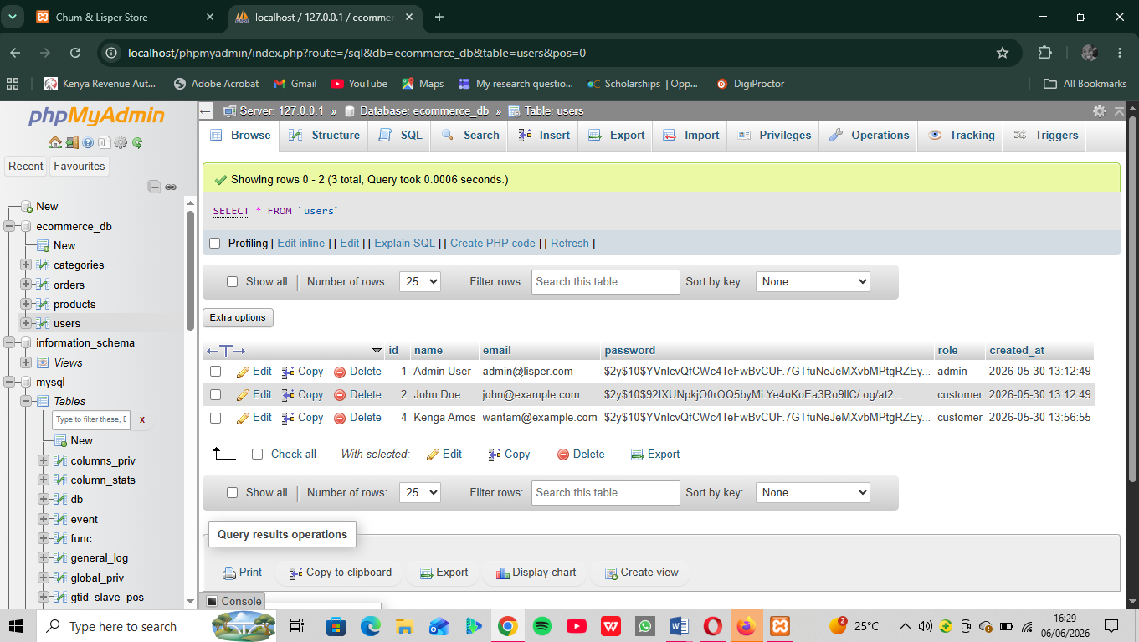
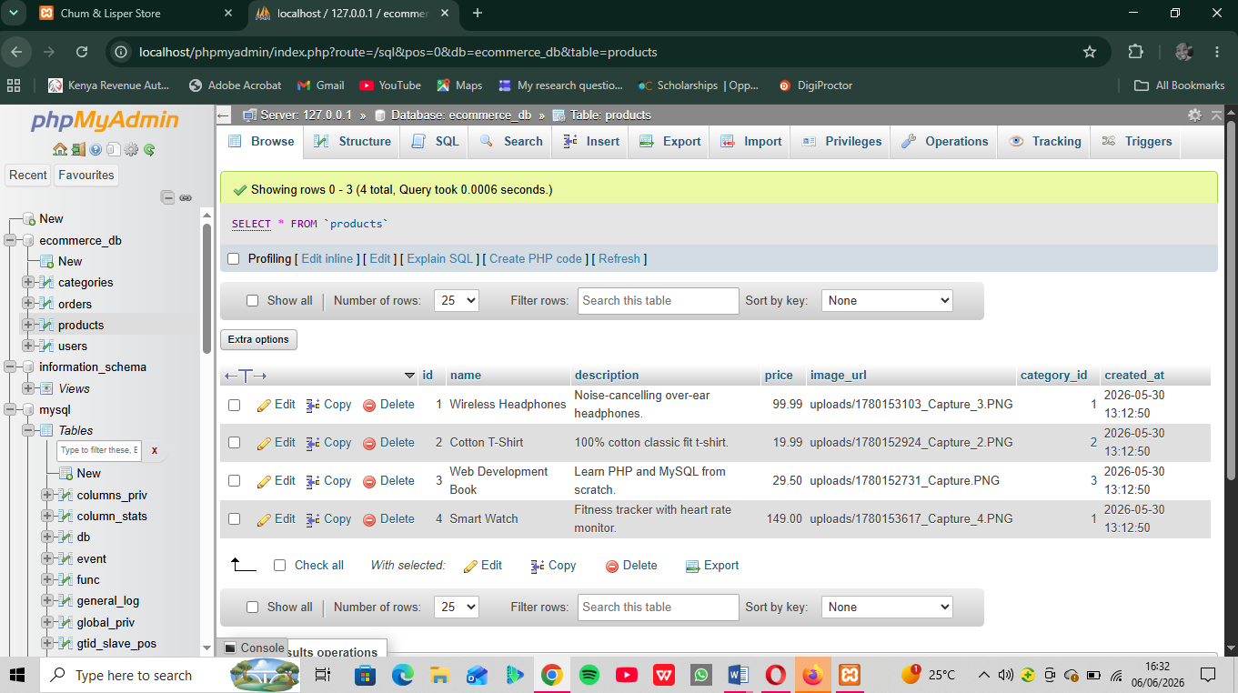

Fig 5: Edit query Updating User Information
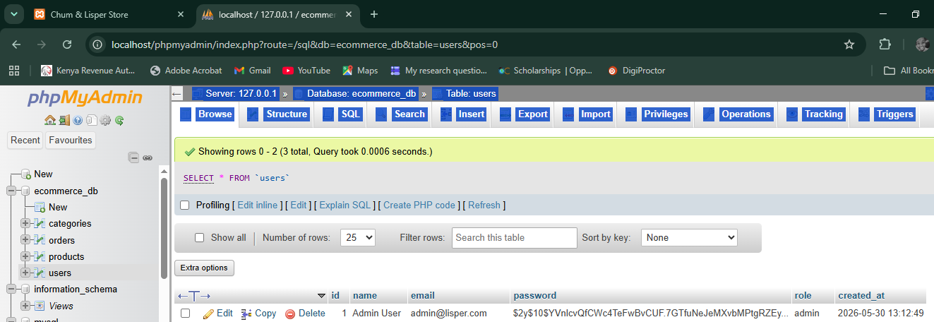
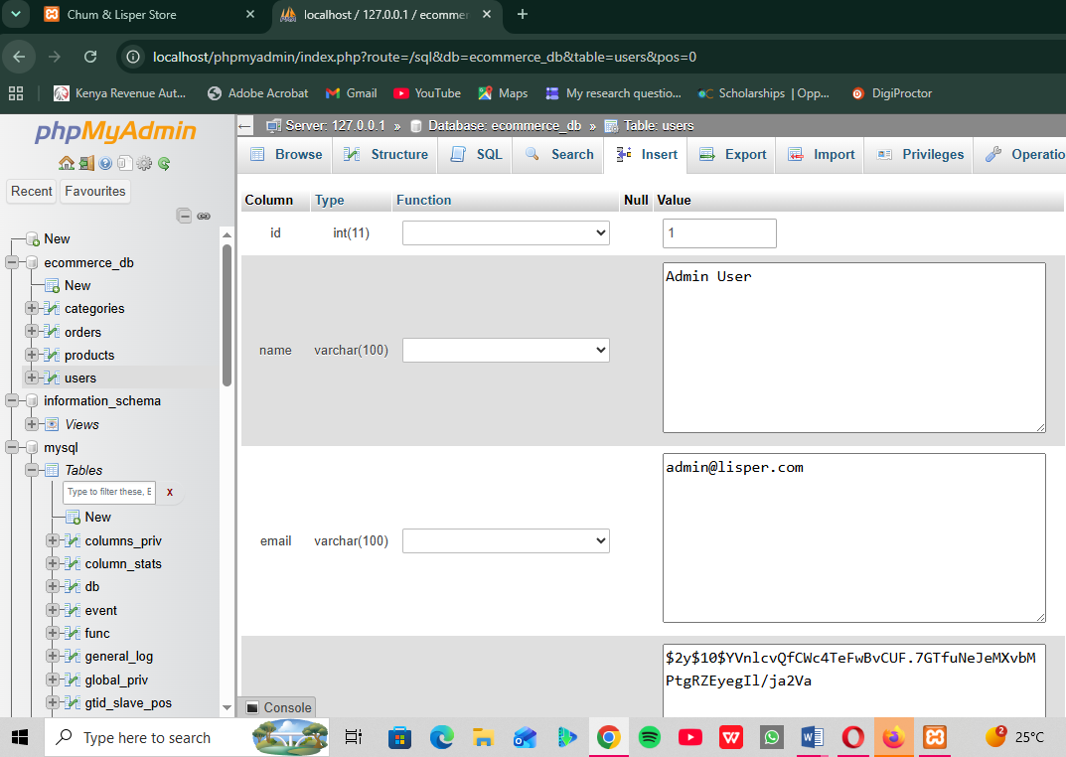

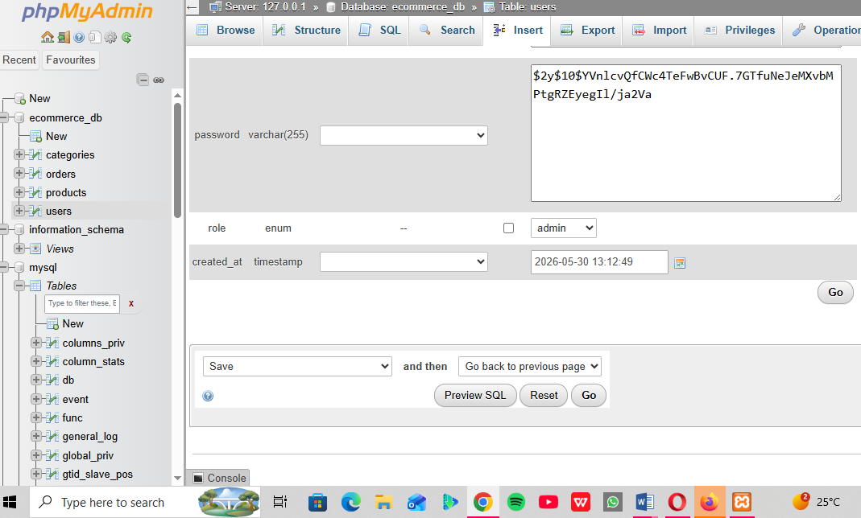

Fig 6: Delete Query Removing a record successfully (codes)

DELETE FROM users WHERE username= ‘admin’;

DELETE FROM products WHERE product name= ‘Smart Watch’;

DELETE FROM customer WHERE name= ‘Kenga Amos’;

Reflection: This week I learned how to build database-driven systems. Fig 1–3 show the creation of student, product, and authentication databases. Fig 4 demonstrates table setup for user credentials. CRUD operations (Fig 5–8) allowed me to add, view, edit, and delete records, proving full database functionality. These tasks taught me how backend systems manage persistent data and connect to frontend forms. The main challenge was ensuring queries executed correctly, which improved my understanding of SQL syntax and database integration with PHP.

WEEK 6

Title: Database Integration and CRUD functions

Fig 1: Connect to MySQL using db.php
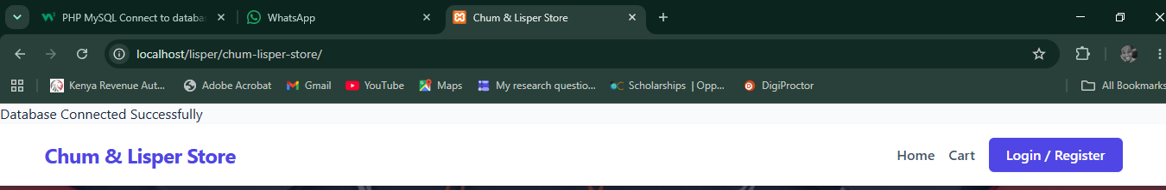

Fig 2: CREATE Operations to Insert Products Records
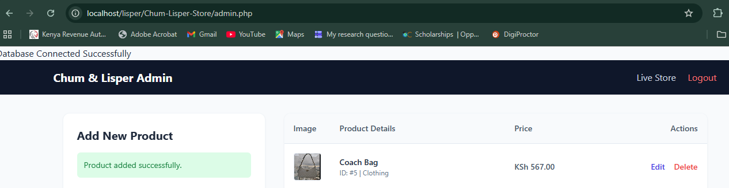

Fig 3: READ Operation to Display Products Records
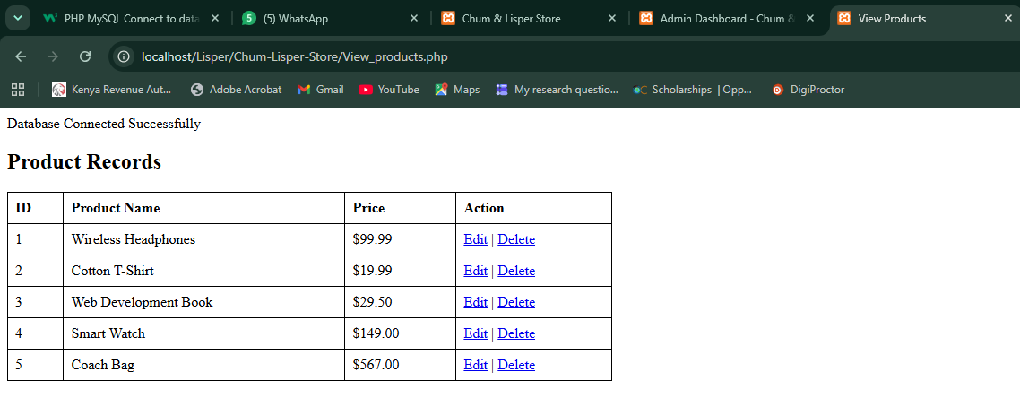

Fig 4: UPDATE Operation to edit products Records
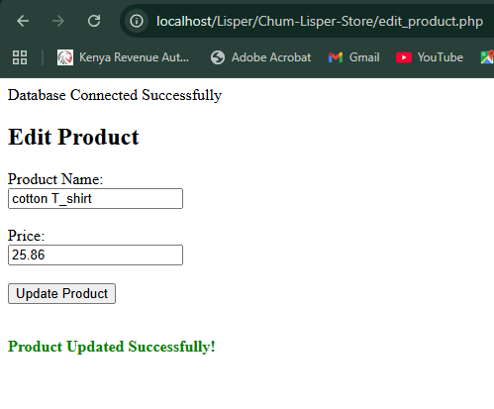

Fig 5: DELETE Operation to delete product record
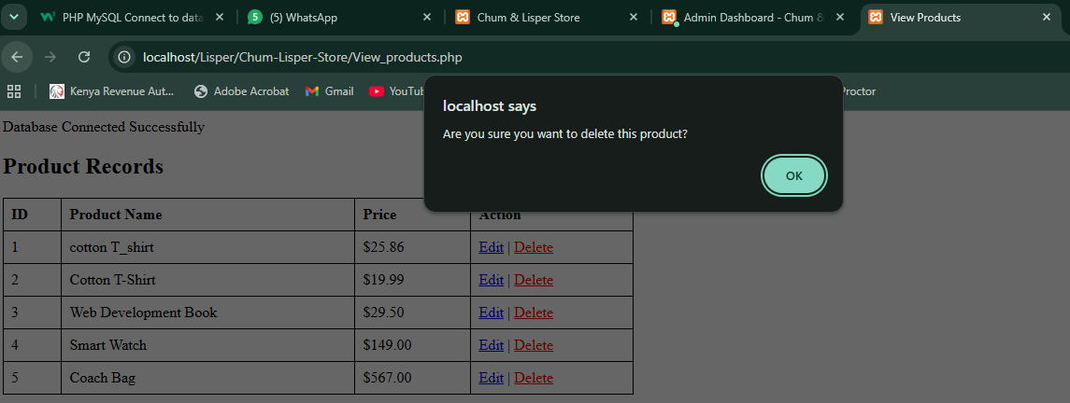

Reflection:
During week six, I integrated a secure MySQL database connection into my e-commerce system using PHP Data Objects (PDO) and developed core CRUD operations. I established a centralized configuration file to maintain organized connectivity before creating explicit user interfaces for managing store inventory. I structured input forms for product registration, generated clean HTML data tables to pull active database records, built editing panels to modify details safely, and deployed interactive JavaScript confirmation dialogs to intercept accidental data removal. This process solidified my understanding of how relational back-end records interact with dynamic full-stack user environments.

WEEK 7

Title: User Authentication and Session Management

Fig 1: Creating a User’s Table

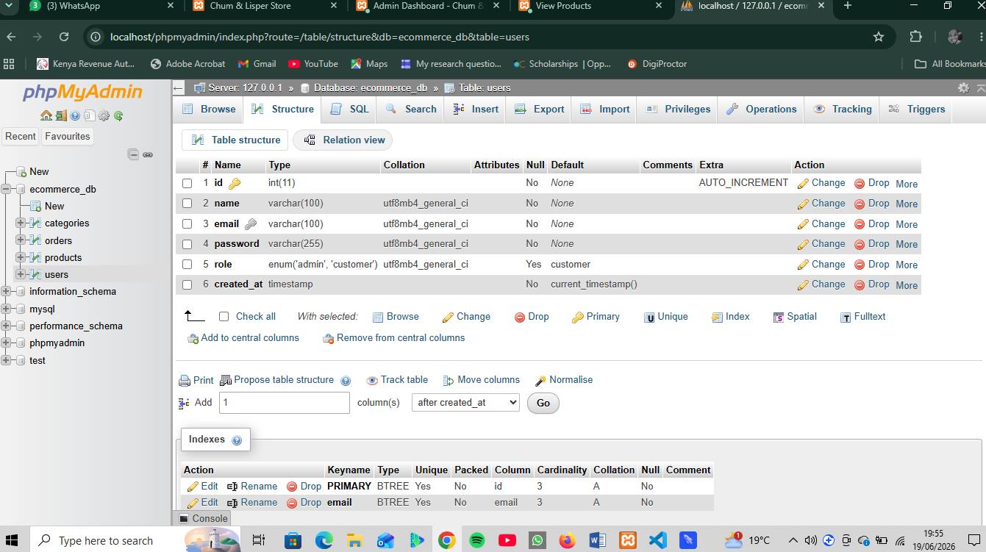

Fig 2: User Registration System

Registration form
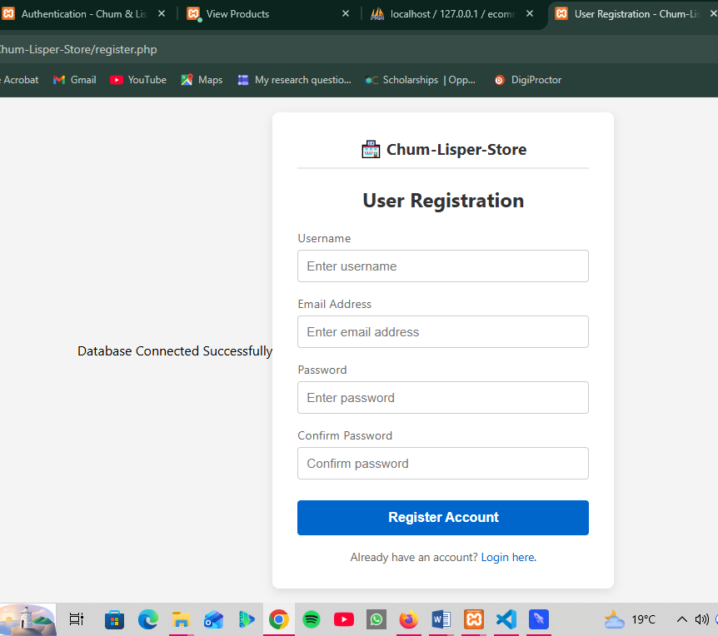

Fig 3: Processing Registration
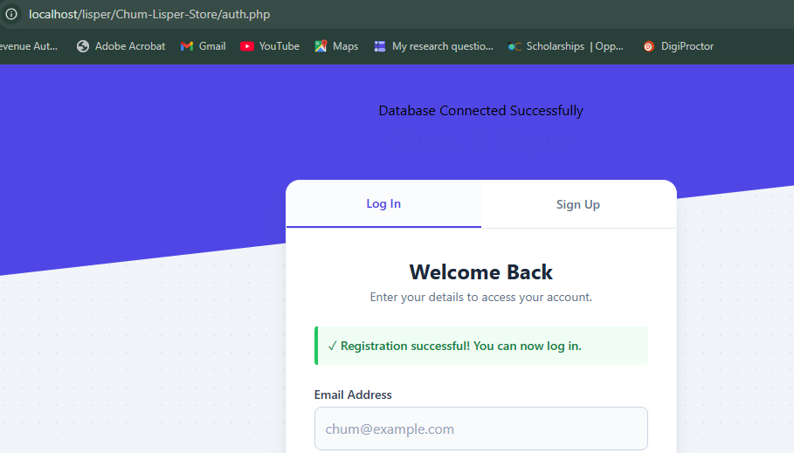

Fig 4: Why use of Hash Passwords
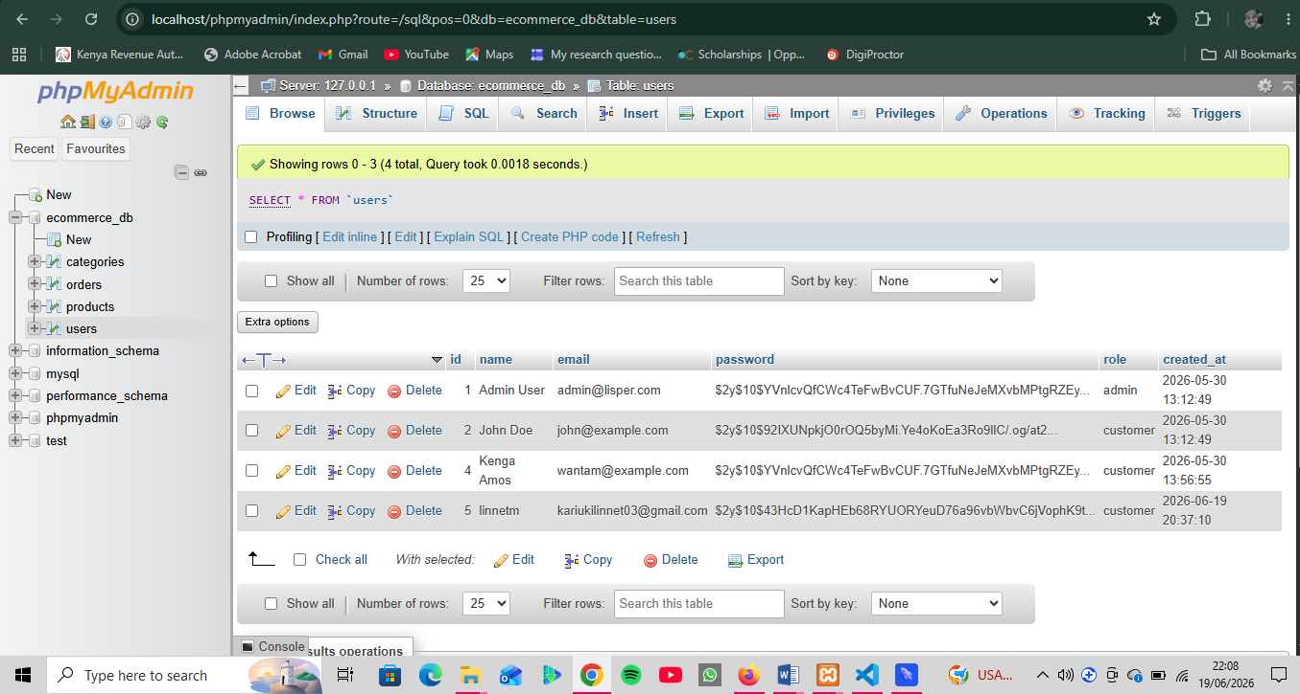

Explanation for use of Harsh:
In Fig 4 above: Database Storage of Hashed User Passwords
As shown in the screenshot above, user passwords are not saved in "plain text" (such as 12345 or mysecretpassword). Instead, the system processes them through PHP's native password_hash () function, converting them into an irreversible, unique 60-character cryptographic string (like $2y$10$X...).

Task: Login System

Fig 1: Login Form
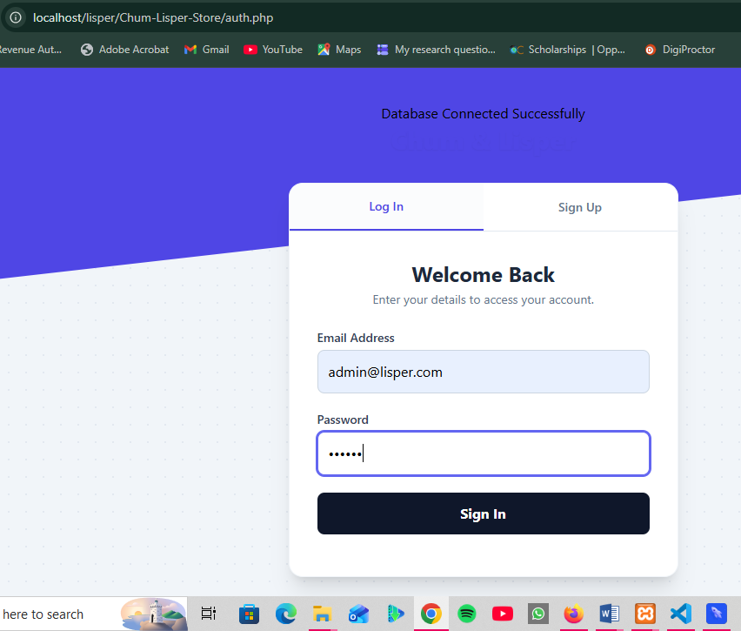

Fig 2: Login Processing
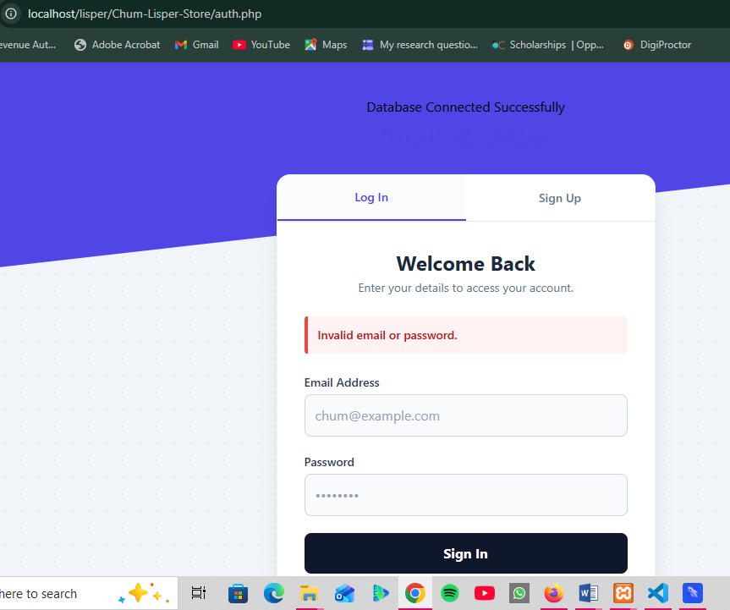

Task: Session Management

Fig 1: Starting a Session
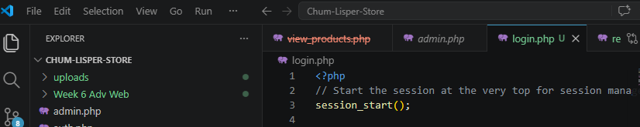

Fig 2: Creating Session Variables
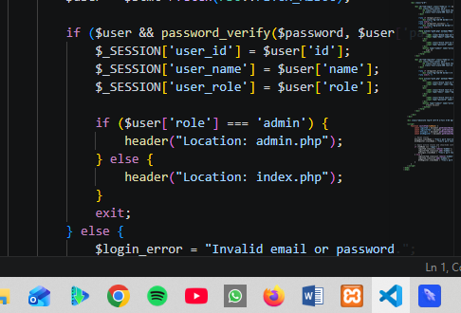

Fig 3: Protecting Pages
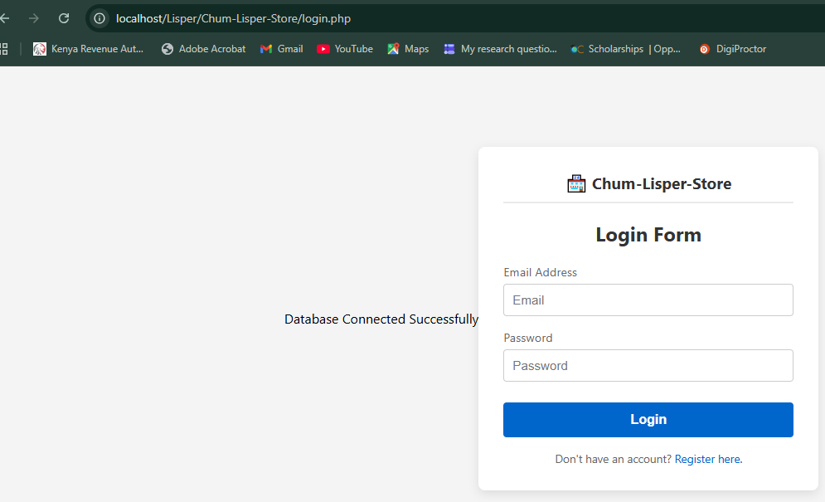

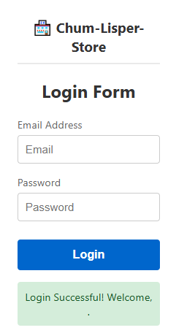

Task: Logout System

Fig 1: Logout Script
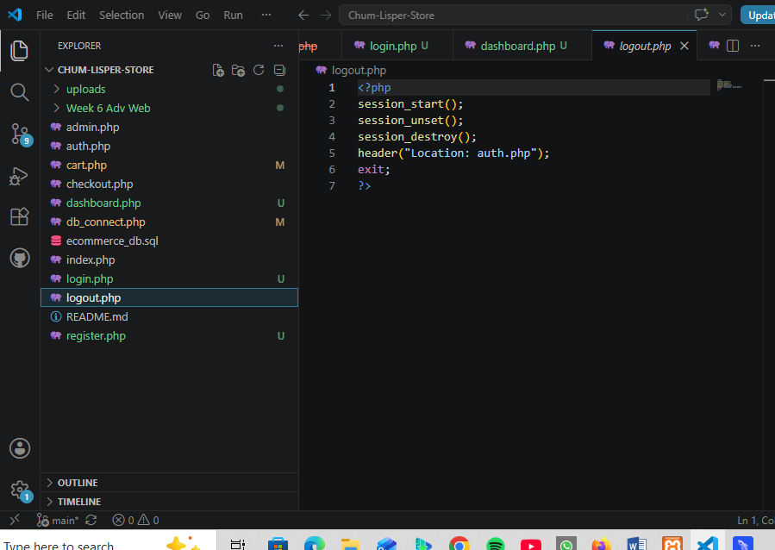

Reflection:
During week seven, I implemented user authentication and session management for my e-commerce system. I constructed a user’s database table to systematically store registration details and used PHP's native password_hash() function to secure user credentials as encrypted strings. I then developed an integrated login script that validates entries using password_verify() and initializes global $_SESSION tokens upon successful authentication. Finally, I deployed access-control gates at the top of protected pages to automatically redirect unauthorized, unauthenticated traffic back to the login form, solidifying my practical understanding of server-side state tracking and defensive security.

